МИНИСТЕРСТВО ОБРАЗОВАНИЯ И НАУКИ

Нижегородский государственный университет им. Н.И. Лобачевского

Е.Ю. Ливанова, Е.П.Андрианова,

Современные международные экономические отношения

Учебно-методическое пособие

Рекомендовано методической комиссией факультета ФИС
для иностранных студентов, обучающихся в ННГУ по направлению подготовки 38.03.01 «Экономика» (бакалавриат)
на английском языке

Нижний Новгород
2014

УДК 339.9.01
ББК 65.5я73-1

Андрианова Е.П. Ливанова Е.Ю. Современные международные экономические отношения. Учебное пособие. – Нижний Новгород: Нижегородский госуниверситет, 2014. – 38 с.

Рецензент: д.э.н., профессор,
заведующий кафедры экономической теории
и методологии ИЭП, А.В. Золотов

В настоящем пособии изложены учебно-методические материалы по курсу “Современные международные экономические отношения” для иностранных студентов, обучающихся в ННГУ по направлению подготовки 38.03.01 «Экономика» (бакалавриат) на английском языке
Учебно-методическое пособие предназначено для студентов факультета иностранных студентов обучающихся по направлению подготовки 38.03.01 «Экономика» и может быть использовано школьниками старших классов, занимающихся научной работой в рамках НОУ.

УДК 339.9.01
ББК 65.5я73-1
© Нижегородский государственный
университет им. Н.И. Лобачевского, 2014

Ministry of Education and Science of the Russian Federation

State educational institution of higher education
«Lobachevsky State University of Nizhniy Novgorod»

Elena Livanova, Elena Andrianova

Contemporary International Economic Relations

Tutorial

Recommended by the Methodical Commission
of the Faculty of International Students for International Students, studying at the B.Sc. Programme 41.03.04 “Economics” in English

Nizhniy Novgorod
2014

Contents

Topic 1. International Economic Relations as a Part of International Social Relations. 5
Topic 2. Emergence and Development of International Relations AND ITS participants 11
Topic 3. Forms and the System of International Economic Relations 14
Topic 4. Globalization of the Economy, Its Nature and Consequences 20
Topic 5. Regionalization of the Global Economic Space 30
Topic 6. Economic Development 32

Topic 1. International Economic Relations as a Part of International Social Relations.
International relations - a system of political and military, political, social, economic and other relations between states and other participants in world politics, which forms the world order.
A unified theory of international relations does not exist. For centuries, the doctrines of national security were based on creation of military and economic power. In today's world, national security is associated with belonging to a particular status communications, such as the NATO or the WTO. Globalization has posed new requirements to national security issues, and revealed tendencies to blur status boundaries. Main priorities of national security are changing. Targets in information wars and conflicts are, along with material ones, are values, which can be protected with a sense of national pride and civilizational identity.
One of the distinctive features of the modern world economy is the rapid development of international economic relations (hereinafter - IER). The subject of international economic relations is the study of two major components: the actual international economic relations and the mechanism of their implementation.
• IER include a set of economic relations between individual countries, their regional associations, and individual companies (transnational and multinational corporations) in the world economy system. IER does not study foreign economies, but their economic relations peculiarities.
• The IER mechanism includes legal norms and instruments for their implementation (international economic treaties, agreements, "codes", charters and so on.), and activities of international economic organizations to achieve the goal of IER.
Consequently, the world economy is an objective basis IER, an important component in dealing with problems IER.
IER (mostly trade) existed before the emergence of the world economy. For example, IER between individual European countries, within different regions (Europe – North Africa, Europe – Middle East). They had an inter-country, narrow regional nature. With the emergence and development of the world economy, IER broaden and deepen the scope of its existence, acquire global nature. Based on the specialization of individual economies, IER are heavily dependent on them. However, as they get implemented, IER become an independent phenomenon following its own laws. IER are a form of existence and development of the world economy, its internal mechanism. The modern world economy is a set of national economies, which are in close interaction and interdependence, subordinate to the objective laws of the market economy.

World market and the international movement of goods and production factors
Development of the simplest form of the internal market refers to an early stage of development of commodity economy based on the division of labour. Almost immediately after their emergence, markets began to specialize. National markets of goods appeared, within which retail markets separated from wholesale, also appeared labour markets, capital markets, and, most importantly, a part of the market got focused on foreign buyers. The great geographical discoveries resulted in the active development of the export of goods to the newly discovered lands and became the most important factor in the development of capitalism in Europe. The narrow craftsmanship and manufactory base ceased to respond to the market needs, and under the pressure of demand the first half of the 19th century saw a large factory industry, which products could not come sell in the domestic market only, it needed worldwide sales. So, in an era of primitive accumulation of capital local centres of interstate commerce at the turn of 19-20th centuries turn into a unified global market.
The world market is the sphere of ​​sustainable commodity and money relations between two countries, based on international division of labour and production factors.
The world market has the following features:
- is a category of commodity production, which went beyond the national framework for marketing their products;
- manifests as the interstate movement of goods;
- optimizes the use of production factors, prompting the manufacturer, in which industries and regions, they can be used most effectively;
- performs a sanitizing role by omitting from the international exchange goods and their producers, who are unable to provide an international standard of quality at competitive prices.
The main external feature of existence of the world market is the movement of goods and services between countries – international trade. International trade consists of two counter-flows of goods – export and import, and is characterized by trade balance and trade turnover.
Further development of the world market of goods leads to participation of production in it. The world economy – a set of national economies of the world, connected by mobile factors of production.
- The basis of the world economy is the international division of labour and other production factors (the international movement of production factors);
- The related growth international forms of production at enterprises, which are located in several countries, especially within of transnational corporations;
- States' economic policies providing for support to the international movement of goods and production factors on a bilateral and multilateral basis;
- Emergence of an open economy between states and intergovernmental organizations.
Within the framework of the global economy, individual economies are becoming more open and focused on international economic cooperation.
International economic relations are a variety of economic (scientific, technical, industrial, commercial, financial and monetary, monetary and information) relations of national economies based on the international division of labour. IER system has a number of significant features:
- Economic relations cover a significant territory that goes beyond national borders;
- Additional resources by composition and volume are engaged;
- Production factors and its results move beyond individual countries at the international level;
- Special tools and instruments (financial, currency, customs, etc.), support the world economy;
- Special international organizations and structures provide economic connections between countries;
- International information relations play a special role;
- New information technologies transform the system of international economic relations, financial and settlement operations.
Thus, the most important factor in the emergence IER is the international division of labour.

International division of labour and internationalization of economic life
Economic progress of the society is associated with the division of labour. At the enterprise level, this is a specialization of employees on individual operations and processes. As a result, production increases, production time decreases, and productivity increases. Social division of labour acts as an objective precondition and an exchange factor: many different products and services are produced, and all large sets of needs are met through exchange. The production process involves separation and specialization of different types of works, as well as their co-operation and interaction. Gradually, the division of labour goes beyond national borders and becomes international. International division of labour is a stable, expanding basis for interaction of national economies, large-scale permanent links between entrepreneurs and enterprises around the world. This is the essence of the internationalization of economic life and activity.
International division of labour is the stage of social territorial division of labour between countries. Classification of the international division of labour reflects the corresponding stages of development of the productive forces:
- International division of labour of a general type, i.e. by spheres of production (mining, processing, industry, agriculture) is characteristic of the period of extensive development of the economy and depends on natural, natural and geographical conditions of production;
- When division of labour of a particular type along with natural ones occurs, great importance is attached to technological, qualification factors, international specialization in certain sectors, sub-sectors and types of production develops, a qualitatively new base of international exchange of goods and services emerges and expands, and their range diversifies, growth of trade between countries accelerates;
- Transition to the international division of labour of an individual type involves specialization in individual operations (items, assemblies, assemblies, components, components) and process steps.
Thus, the international division of labour (IDL) as a global system of division of labour between national economies provides specialization in the production of certain products and services.
Implementation of the advantages of the international division of labour in the international exchange of any country under favourable conditions provides the following: 1) the difference between international and domestic prices of exported goods and services; 2) internal costs savings due to refusal of the national production while using cheaper imports.
The main direction of development of the international division of labour in recent decades has been the expansion of international specialization and cooperation in production. International specialization of production (ISP) develops in two directions – industrial and territorial. Industrial direction includes cross-industry specialization; intra-industry specialization; specialization of individual enterprises. Territorial ISP includes specialization of individual countries; groups of countries; regions based on production of certain goods and their parts for the world market.
The international co-operation in production covers various areas of co-operation:
- Production and technological cooperation, including: a) transfer of licenses and use of property rights; b) development and agreement of the design documentation, processes, a product technical level and quality, construction and installation works, modernization of cooperating enterprises; c) improvement of production management, standardization, harmonization, certification, and allocation of production programs.
- Trade and economic processes associated with the implementation of cooperative production, namely interconnected products between cooperants and a third person in partner countries.
- After-sales service of equipment.
Joint ventures have become widespread – joint activities of business partners from two or more countries in production, trade, investment and service areas. To coordinate business activities, consortiums (temporary alliances of companies, firms and organizations) are created that transform the existing IDL into an inter-corporate one carried out by transnational economic entities.
During the information age, Manuel Castells highlights the following types of IDL:
- manufacturers of high value based on informed labour;
- manufacturers of high volumes based on low-paid labour;
- producers of raw materials based on natural resources;
- redundant producers whose work is devalued.
For the analysis of causal relationships in macroeconomics, the international economy is viewed as a set of four economic sectors: real, fiscal, monetary and external. Key links between the sectors are defined through a system of national accounts (hereinafter - SNA) – a set of internationally recognized rules of economic activity accounting. The basis for accounting are institutional units (non-financial corporations, households, not-for-profit institutions, government agencies and financial corporations), who can own goods and assets, have economic liabilities and carry out transactions with other agents on their own behalf. Their activities accounts record either flows that define the activities of the institutional unit for a certain period of time, or stocks that characterize the residual value of any indicator at any given time. Institutional units (residents and non-residents) carry out international economic transactions, in which ownership of tangible or financial assets is transferred or services are provided. On the external sector’s accounts all transactions between residents and non-residents are reflected. Classification of international business operations in the SNA is close to the classification of balance of payments, but not identical to it, it treats trade in goods and trade in services separately from the movement of capital and it treats other production factors separately.
The most important are relationships of balance of payments, including basic operations of the external sector of the economy, with the corresponding indicators of the internal sector: items of national income and gross national product, the monetary sector and the public sector. In each of these accounts, there is an international element, which is directly related to the balance of payments, reflecting the interaction of the economy with the outside world.
Division of macroeconomics into sectors of economic activity and the determining of basic economic relationships between them, allows us to analyze trends in the development of individual countries and to compare them with each other. Globally, there are about 200 different countries in terms of economic development. Knowing their classification is important for mutual study and exchange of experiences of economic development.
Within the framework of the international economy, a country is deemed to be not only a territorial unit that is a state, but also some territorial units that are not states, but have their own and independent economic policy and keep individual statistical records of their economic development. These are some island dependent territories of the United Kingdom, the Netherlands and France, which are not independent states, but are treated as separate countries.

Topic 2. Emergence and Development of International Relations AND ITS participants
In the economic literature there is no common understanding of the term ‘world economy’, but several approaches can be singled out.
- The world economy is the sum of national economies interconnected by the system of international division of labour, economic and political relations. In this definition, the main components are nationally independent countries, regardless whether their production oriented to the domestic or foreign market.
- According to another point of view, the world economy is considered as a system of international economic relations (IER), as general, universal relationships between the national economies. It includes trade, financial relations, as well as the unequal distribution of capital resources and labour. In this case, production, which largely determines the international economic relationships, drops from the view of the researcher.
The world economy is a system. Characteristic features:
- Integrity, which suggests economic interaction of all system components at a relatively stable level.
- Multiple constituent elements, hierarchy, multiple levels and structure.
- The foundation of the system – international and limited by individual states national production of material and non-material goods, their distribution, exchange and consumption.
- The general objective is to meet the needs (demand), but in different subsystems, this goal is modified due to various socio-economic conditions.
- The order based on the norms of public and private international law, which governs economic relations between states, economic associations, legal entities and individuals.
- A complex economic system, which consists of separate elements (subjects), which are systems themselves with their inherent government.
Relationships between individual elements of the world economy are arranged as levels. Relationships between states form the international level, which is governed by international rules and norms. Relationships of flows going beyond national boundaries form the transnational level – the sphere of activity of firms and groups with their internal information systems.
In socio-economic terms, the world economy is inhomogeneous. In production and social terms the world economy is an arena of conflict and competition, which are present both within countries and on a global scale.
Subjects of the world economy
The subjects of the world economy are economic units with capital, and capable of organizing production activities in the international economic space and having certain international rights and obligations. The subjects of the world economy include:
- National states,
- Transnational corporations,
- Regional integration business associations,
- International economic organizations.
Formation of the world economy. Development of productive forces and national economy system in the second half of the 19th century led to fundamental changes in their relationships. Formation of the world market helped to increase the level of socialization of productive forces on an international scale. The emergence of the global economic system was due to development of international production, based on product output by one economic entity in different countries and development of economic exchange with other countries and territories. Development of international production associated with the spread of the colonial and semi-colonial dominance of a small number of countries into new territories and their forced inclusion into the reproduction process. Colonialism was one of the conditions for forced economic unification of the world.
Prerequisites of formation of the world economy (WE):
- Colonial expansion.
- Export of capital.
- International exchange.
- Economic growth in the last third of 19th century.
The world economic system established at the turn of 19-20th centuries was composed of the industrialized capitalist countries and agricultural and raw exports colonial and dependent countries.
The world economy of the late 19th - early 20th century is different from the WE of 1960-90s of the 20th century – at the beginning of the 20th century it was based on military force and non-economic coercion, there were contradictions between the imperialist countries (which led to two world wars), as well as between developed and developing countries.
- In the middle of the 20th century, the world economy is split into two parts: global capitalist and global socialist. In the early 1990s, 9/10 of the international trade is the trade turnover of the global capitalist economy. From the 1960s the WE included developing countries, and by the mid-1970s "new industrialized countries" emerged among them. After the collapse of the Soviet Union, the world economy acquires features of a single, unified formation. The world economy at the turn of the 21st century is global in scope; it is based on the principles of market economy, the laws of the international division of labour, the internationalization of production and capital.
The general tendency of development of the world economy is movement towards creation of a single market of global capital, goods and services, economic convergence and integration of individual countries into a single world economic complex. The modern level of international economic relations is characterized by:
- Transformation of bilateral IER to multilateral;
- Transformation of the international trade into a means of servicing national production processes;
- Intensification and globalization of migration of capital;
- Active exchange of scientific and technical knowledge;
- Increasing labour migration;
- Accelerated and expanded integration of the economies of countries and regions.
The main feature of the present stage of the IER is gradual convergence of the economic development levels of different countries, which is affected by:
- Transfer from industrial to post-industrial society.
- Technological revolutions.
- Aggravation of energy and raw materials and food problems.
- Environmental problems.
Conclusion:
Transformation (transit) of the IER is characterized by the transition from one world order to another, and is manifested in the international division of labour, search for new forms of international cooperation. The world economy is greatly influenced by geo-economic conflicts – trade and information wars. Transformation of the modern IER is characterized by the transition from a bipolar world order to the new system of liberalization and the international division of labour. Capital flees from production, international and commercial banks are the centre of the new economic relations. International division of labour is transformed into the inter-corporate one, carried out by transnational economic entities. The main subject of the IER is not a material, but an intellectual product.

Topic 3. Forms and the System of International Economic Relations
The world economy as a complete system consists of various parts, subsystems, which have a certain common features and differences.
To determine subsystems of the world economy a number of criteria is used:
- Socio-economic structure of the economy;
- Level of economic development;
- Type of economic growth;
- Level and nature of foreign economic relations;
- Level and quality of life.
The socio-economic structure of the economy is based on implementation of forms of ownership. The implementation of economic ownership is manifested primarily in a compound of the means of production to the labour force, and the important role played by the specific legal forms of enterprises and economic activities
The level of economic development is characterized by the volume of GDP and GNI per capita, degree of industrialization of the economy (share of industrial production) and the structure of production.
Gross National Income (GNI) is the total value of all goods and services produced within a year on the territory of a state (that is gross domestic product, GDP), plus income received by citizens of the country from abroad, minus income taken from the country by foreigners.
The source of information is the database of the World Bank “World Development Indicators”, and it is recorded during the fiscal year (ending June 30) and updated annually (adjusted statistics are usually published in the October-November).
As of July 1, 2013 all states and territories are classified in the categories:
- Countries with high per capita income (from $12,616 and up);
- Countries with low levels of per capita income (from $1,036 to $12,615):
- Countries with upper middle income (from $12,615 to $4,085);
- Countries with a lower middle-income (from $4,085 to $1,036).
- Countries with low per capita income (from $1,035 or less).
In terms of national income per capita, the five richest countries in the world in 2013 are: Monaco ($186,950), Liechtenstein ($136,770), Bermuda ($106,920), Norway ($98,860), Switzerland ($82,730). However, their combined share in global output is less than 1%. The per capita income in the United States amounted to $50,120. In Russia, this figure was $12,700 – the highest value among the CIS countries and 59 in the world in 2013, Russia joined the group of countries with incomes above the average. In 28 countries, the GDP per capita is less than $1,000, the poorest country in the world is the Democratic Republic of Congo, where the annual income is approximately $220 per person.
Type of economic development (extensive and intensive) expresses the quantitative and qualitative changes in the production of goods and services.
The role of the external sector in the national economy is reflected in export and import of goods and services, movement of capital. The main indicators characterizing the role of foreign economic relations are export and import quotas for goods and services, the commodity structure of foreign trade, the nature of participation in the international movement of capital, technology, labour, and degree of openness of the economy.
Openness of the economy is generally considered in the functional, organizational, institutional aspects.
By the open economy we understand such an economy, the direction of which is determined by the trend present in the world economy, and foreign economic relations strengthen, while the foreign trade turnover reaches a point where it begins to stimulate or inhibit the overall economic growth.
The criterion of the open nature of the economy is the coefficient of elasticity of foreign trade to GDP.
In the economy of a closed nature the structure of production depends of the country's capital and resources, and on the structure of domestic demand. For an open economy characterized by the international division of labour in many ways defines the internal structure of production.
The amount of the economic potential depends on the scale of the productive forces, population, size of the territory, and richness of natural resources.
Level and quality of life.
Typology of countries of the world
Typology of countries is the allocation of groups of countries with similar type and level of socio-economic development. Determining the type of the state means to refer it to a particular socio-economic category. Data from universal international organizations, whose members are the countries most of the world – the United Nations (UN), International Monetary Fund (IMF) and World Bank (WB) provide an idea of groups of countries in the global economy. Evaluation of groups of countries in the international economy by these organizations is somewhat different, since the number of countries–members of these organizations is different (UN - 185, IMF - 181 WB - 180), and international organizations monitor only economies of their member countries.
Currently, the UN has now two classifications of countries. In the first one, all countries of the world are divided into three types: 1) economically developed countries; 2) developing countries; and 3) countries with economies in transition (from a planned to a market). In this case, the third type are actually former socialist countries, which carry out economic reforms for building a market economy. According to the second classification, the UN identified two broad groups of countries: 1) economically developed and 2) developing. With such a division one group of countries includes very different states. Therefore, within each type smaller groups are formed – subtypes.
Economically developed countries of the United Nations include 60 countries: all Europe, USA, Canada, Japan, Australia, New Zealand, South Africa, Israel. These countries are characterized by a high level of economic development, the prevalence of manufacturing industries and the service sector in the GDP, a high standard of living. Due to heterogeneity economically developed countries are divided into several subtypes:
Major countries - the United States, Japan, France, Germany, Italy, United Kingdom. They provide more than 50% of the total industrial production and over 25% of world agricultural production.
Economically developed European countries – Switzerland, Belgium, Netherlands, Austria, Scandinavia and others. They are characterized by political stability, high standards of living, high GDP and the highest rates of exports and imports per capita. They are more specialized in the international division of labour, and the economy is greatly dependent on income derived from banking, tourism, trade and brokering, etc .;
Countries of "resettlement capitalism" – Canada, Australia, New Zealand, South Africa (former British colonies), and the State of Israel established in 1948 by the resolution of the UN General Assembly. A characteristic feature of these countries (except Israel) is the preservation of international specialization in the export of raw materials and agricultural products, which is based on high productivity and the developed domestic economy.
Middle-developed countries:
1. middle-income countries of Europe: Greece, Spain, Portugal, Ireland - by the level of development of the productive forces they somewhat lag behind modern technological progress.
2 transition economies: CIS countries, Eastern Europe and China. They implement reforms aimed at the development of market relations in the economy instead of central planning.
By the UN classification developing countries include 132 countries of Asia, Africa and Latin America characterized by low and middle-income. Due to a large variety of developing countries, in the international economy they are usually classified by geography as well as by different analytical criteria:
The level of economic development (high, medium and low GDP per capita);
The level of development of capitalism as an economic way (with a predominance of foreign and state capital, "enclaves", the least developed countries with fragments of capitalism).

The IMF classification is based on two criteria: industrialized countries (industrialized developed countries) and the rest: emerging economies and developing countries. The classification applies only to countries that are members of the IMF, and does not refer to China and Cuba – their economies are not monitored by the IMF. Countries with unarranged base of economic data are not included in the classification: Brunei, Afghanistan, Eritrea, Bosnia and Herzegovina, Somalia, Serbia and Liberia.
Each of the groups is divided into subgroups. Thus, in the group of industrialized countries, consisting of 29 members, there are subgroups of the "Big Eight", the Euro area countries and the new industrialized countries of Asia.
A group of "Other countries" with emerging and developing is more numerous – 143 countries, which are home to 85% of the world population.
In addition to the above classification the IMF classifies countries as follows:
• regional groups (Africa, Middle East, CIS, Developing Asia, Central Asia, Americas, Central and Eastern Europe);
• analytical groups, including the sources of export earnings (fuel, non-fuel, primary processing products);
• external sources of financing (net debtor countries).
Currently, the IMF introduced the term "advanced economies" to refer to countries and territories that traditionally referred to developed ones (this is 23 countries). Advanced economies also include South Korea, Singapore, Hong Kong, Taiwan, Israel and Cyprus.

Key indicators of development of the world economy
For analysis of the economic situation of the world a number of indicators that characterize the dynamics and the state of the global economy are used. The key ones are the gross world product and the world's wealth.
Gross world product (GWP) expresses the total amount of ultimate goods and services produced in all countries of the world, regardless of the nationality of companies operating there for a certain period of time. Accounting of the ultimate product provides for exclusion of double accounting of raw materials, semi-finished products and other materials, fuel, electricity and services used in the process of its production.
In each country, the gross domestic product is calculated based on the system of national accounts. Calculation of results of operations is carried out based on three principles: production, use and income.
Components of the GWP cover the main areas, industries and factors of economic development. Considering by the main components of the use of GWP gives an understanding of the main sectors of demand, and the analysis of the GWP by production shows changes in the structure of the whole economy and major industries. The GWP helps to indicate the rating of the country and regions in the world production, the social productivity of labour in different time periods.
At the national level, the GDP is measured in current and constant prices of any given year. Calculation of GWP is effected in a single currency – dollars at current and constant exchange rates. Calculation of GDP based on purchasing power of currencies gives a more complete picture of the country's economic potential.
According to the World Bank, the GWP in 2013 amounted to $71,666,350 million. (Compared to $69,971,508 million in the previous year). The USA remains the undisputable world leader in terms of the economy - $15,094,000 million. The economy of China amounts to $7,298,097 million, Japan ($5,867,154 million) is in third place. They are followed by Germany ($3,399,589 million), France ($2,612,878 million), United Kingdom ($2,435,174 million), Brazil ($2,252,664 million), Russia ($2,014,775 million) and Italy ($ 2,013,263 million). The top ten world leaders closes India ($1,841,717 million). The share of the top five economies account for almost 50% of world GDP.
World’s wealth (WW) – a set of natural resources, created assets, accumulated wealth and intangible assets, which the countries of the world possess.
By the origin, the world's wealth includes natural resources (land, minerals, water, forests) and products of labour accumulated by previous generations. This differs the WW from the GWP, reflecting the results of production for a particular calendar year.
The WW elements include: financial assets and non-financial assets divided into produced and non-produced assets. Produced assets are created through the production and include the basic means of production, main non-productive assets, fixed assets inventories and values. Non-produced assets are not the result of production and are divided into material ones in the form of land, subsoil resources and other natural resources involved in the economic turnover and intangible, such as patents, copyrights, licenses.
In a broad sense, the world's wealth includes non-material values ​​held by the world community of nations; production expertise of people, their educational potential, and scientific and technical ideas, information resources, and cultural values.

Topic 4. Globalization of the Economy, Its Nature and Consequences

Definition
Globalization (or globalisation) is the process of international integration arising from the interchange of world views, products, ideas, and other aspects of culture.^{[1][2]} Advances in transportation and telecommunications infrastructure, including the rise of the telegraph and its posterity the Internet, are major factors in globalization, generating further interdependence of economic and cultural activities.

Etymology and usage
The term globalization is derived from the word globalize, which refers to the emergence of an international network of social and economic systems. One of the earliest known usages of the term as a noun was in a 1930 publication entitled, Towards New Education, where it denoted a holistic view of human experience in education. A related term, corporate giants, was coined by Charles Taze Russell in 1897 to refer to the largely national trusts and other large enterprises of the time. Due to the complexity of the concept, research projects, articles, and discussions often remain focused on a single aspect of globalization.[

Aspects
Global business organization - International business includes all commercial transactions (private sales, investments, logistics, and transportation) According to a recent McKinsey Global Institute report, flows of goods, services, and finance reached $26 trillion in 2012, or 36 percent of global GDP, 1.5 times the level in 1990.
International trade - the exchange of capital, goods, and services across international borders or territories.]
Trade agreements, economic blocks and special trade zones
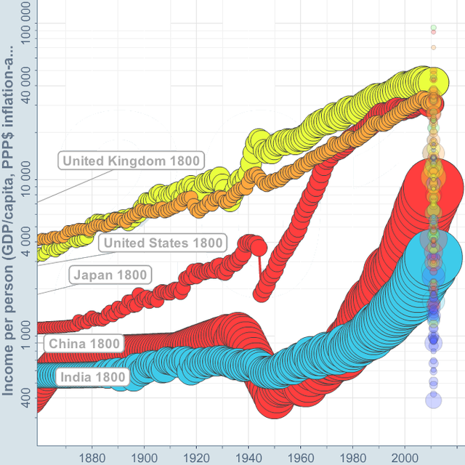
Gross domestic product in 2011 US dollars per capita, adjusted for inflation and purchasing power parity (log scale) from 1860 to 2011, with population (disk area) for the US (yellow), UK (orange), Japan (red), China (red), and India (blue).
Establishment of free trade areas has become an essential feature of modern governments to handle preferential trading arrangements with foreign and multinational entities

Economic globalization
Economic globalization is the increasing economic interdependence of national economies across the world through a rapid increase in cross-border movement of goods, service, technology and capital. Whereas the globalization of business is centered around the diminution of international trade regulations as well as tariffs, taxes, and other impediments that suppresses global trade, economic globalization is the process of increasing economic integration between countries, leading to the emergence of a global marketplace or a single world market. Depending on the paradigm, economic globalization can be viewed as either a positive or a negative phenomenon. Economic globalization comprises the globalization of production, markets, competition, technology, and corporations and industries.
In 1944, 44 nations attended the Bretton Woods Conference with a purpose of stabilizing world currencies and establishing credit for international trade in the post World War II era. While the international economic order envisioned by the conference gave way to the neo-liberal economic order prevalent today, the conference established many of the organizations essential to advancement towards a close-knit global economy and global financial system, such as the World Bank, the International Monetary Fund, and the International Trade Organization.

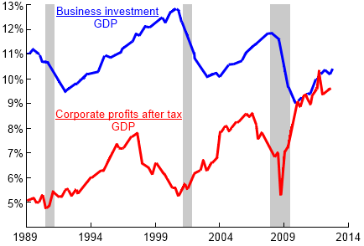
Red: U.S. corporate profits after tax. Blue: U.S. nonresidential business investment, both as fractions of GDP, 1989–2012. Wealth concentration of corporate profits in global tax havensdue to tax avoidance spurred by imposition of austerity measures can stall investment, inhibiting further growth.

Global financial system
By the early 21st century, a worldwide framework of legal agreements, institutions, and both formal and informal economic actors came together to facilitate international flows of financial capital for purposes of investment and trade financing. This global financial system emerged during the first modern wave of economic globalization, marked by the establishment of central banks, multilateral treaties, andintergovernmental organizations aimed at improving the transparency, regulation, and effectiveness of international markets. Theworld economy became increasingly financially integrated throughout the 20th century as nations liberalized capital accounts and deregulated financial sectors. With greater exposure to volatile capital flows, a series of financial crises in Europe, Asia, and Latin America had contagious effects on other countries. By the early 21st century, financial institutions had become increasingly large with a more sophisticated and interconnected range of investment activities. Thus, when the United States experienced a financial crisis early in that century, it quickly propagated among other nations. It became known as the global financial crisis and is recognized as the catalyst for the worldwide Great Recession.

Measuring globalization

Globalization Index
Measurement of economic globalization focuses on variables such as trade, Foreign Direct Investment (FDI), portfolio investment, and income. However, newer indices attempt to measure globalization in more general terms, including variables related to political, social, cultural, and even environmental aspects of globalization.
One index of globalization is the KOF Index, which measures the three main dimensions of globalization: economic, social, and political. Another is the A.T. Kearney / Foreign Policy Magazine Globalization Index.
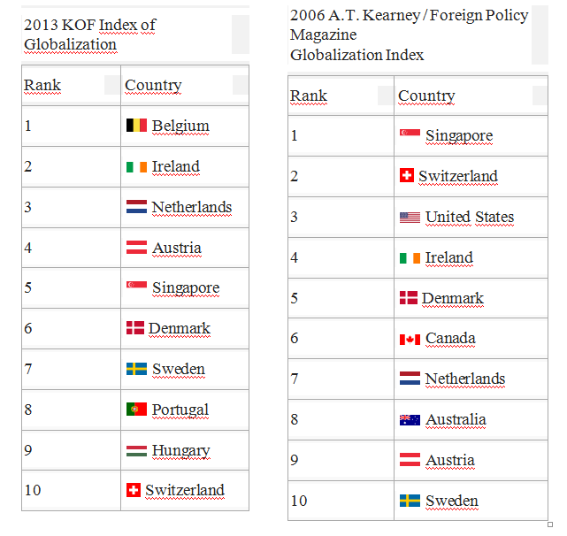

The Good Country Index
The Index is a composite statistic of 35 data points which are mostly generated by the United Nations. These data points are combined into a common measure which gives an overall ranking and a ranking in seven categories such as Science and Technology, Culture, International Peace and Security, World Order, Planet and Climate, Prosperity and Equality, Health and Wellbeing.
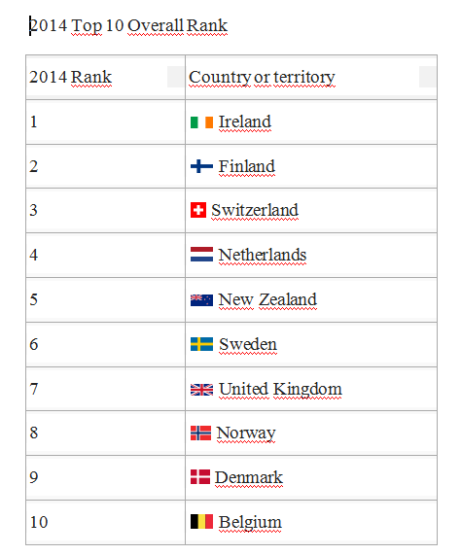

Free trade policies
The Enabling Trade Index measures the factors, policies and services that facilitate the trade in goods across borders and to destinations. It is made up of four sub-indexes: market access; border administration; transport and communications infrastructure; and business environment.
The top 20 countries in The Enabling Trade Index (as of the 2010 report) are:

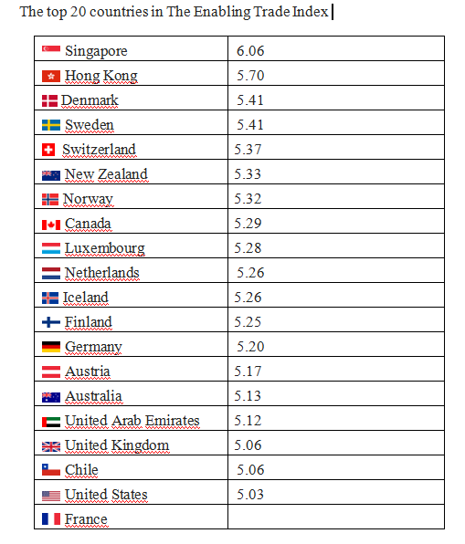

Support and criticism
Reactions to processes contributing to globalization have varied widely with a history as long as extraterritorial contact and trade. Philosophical differences regarding the costs and benefits of such processes give rise to a broad-range of ideologies and social movements. Proponents of economic growth, expansion and development, in general, view globalizing processes as desirable or necessary to the well-being of human society. Antagonists view one or more globalizing processes as detrimental to social well-being on a global or local scale; this includes those who question either the social or natural sustainability of long-term and continuous economic expansion, the social structural inequality caused by these processes, and the colonial, Imperialistic, or hegemonic ethnocentrism, cultural assimilation and cultural appropriation that underlie such processes.

Proponents
In general, corporate businesses, particularly in the area of finance, see globalization as a positive force in the world. Many economists cite statistics that seem to support such positive impact. For example, per capita Gross Domestic Product (GDP) growth among post-1980 globalizing countries accelerated from 1.4 percent a year in the 1960s and 2.9 percent a year in the 1970s to 3.5 percent in the 1980s and 5.0 percent in the 1990s. This acceleration in growth seems even more remarkable given that the rich countries saw steady declines in growth from a high of 4.7 percent in the 1960s to 2.2 percent in the 1990s. Also, the non-globalizing developing countries seem to fare worse than the globalizers, with the former's annual growth rates falling from highs of 3.3 percent during the 1970s to only 1.4 percent during the 1990s. This rapid growth among the globalizers is not simply due to the strong performances of China and India in the 1980s and 1990s – 18 out of the 24 globalizers experienced increases in growth, many of them quite substantial.

Critiques
Critiques of globalization generally stem from discussions surrounding the impact of such processes on the planet as well as the human costs. They challenge directly traditional metrics, such as GDP, and look to other measures, such as the Gini coefficient or the Happy Planet Index, and point to a "multitude of interconnected fatal consequences–social disintegration, a breakdown of democracy, more rapid and extensive deterioration of the environment, the spread of new diseases, increasing poverty and alienation" which they claim are the unintended consequences of globalization.
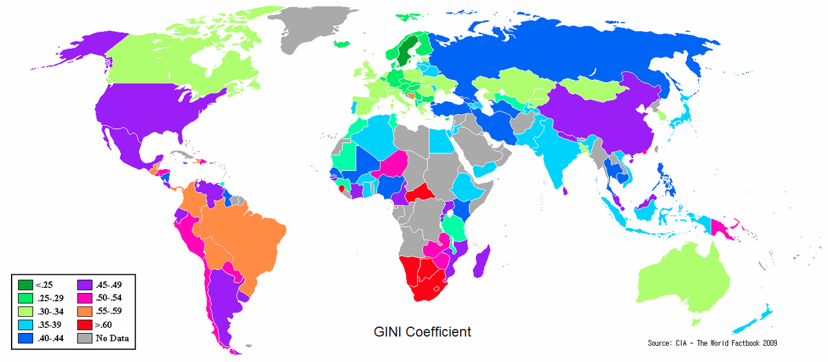
Differences in national income equality around the world as measured by the national Gini coefficient, 2009
Criticisms have arisen from church groups (and,of late, the Pope), national liberation factions, unionists, intellectuals, artists, protectionists, anarchists, those in support of relocalization (e.g., consumption of nearby production) and others. Some have been reformist in nature, (arguing for a more moderate form of capitalism) while others are more revolutionary (power shift from private to public control) or reactionary (public to private).
Some critics of globalization argue that it harms the diversity of cultures. As a dominating country’s culture is introduced into a receiving country through globalization, it can become a threat to the diversity of local culture. Some argue that globalization may ultimately lead to Westernization or Americanization of culture, where the dominating cultural concepts of economically and politically powerful Western countries spread and cause harm on local cultures.
Critics argue that globalization results in:
Poorer countries suffering disadvantages: While it is true that free trade encourages globalization among countries, some countries try to protect their domestic suppliers. The main export of poorer countries is usually agricultural productions. Larger countries often subsidise their farmers (e.g., the EU's Common Agricultural Policy), which lowers the market price for foreign crops.
Joseph Stiglitz argues that countries that have managed globalization on their own have succeeded in reaping benefits from globalization, while countries that were economically managed by international institutions such as the IMF have not gained as much from globalization.
The shift to outsourcing: Globalization allowed corporations to move manufacturing and service jobs from high cost locations, creating economic opportunities with the most competitive wages and worker benefits.
Weak labor unions: The surplus in cheap labor coupled with an ever growing number of companies in transition weakened labor unions in high-cost areas. Unions lose their effectiveness and workers their enthusiasm for unions when membership begins to decline.
An increase in exploitation of child labour: Countries with weak protections for children are vulnerable to infestation by rogue companies and criminal gangs who exploit them. Examples include quarrying, salvage, and farm work as well as trafficking, bondage, forced labor, prostitution and pornography.
Helena Norberg-Hodge, the director and founder of ISEC, criticizes globalization in many ways. In her book Ancient Futures, Norberg-Hodge claims that "centuries of ecological balance and social harmony are under threat from the pressures of development and globalization." She also criticizes the standardization and rationalization of globalization, as it does not always yield the expected growth outcomes. Although globalization takes similar steps in most countries, scholars such as Hodge claim that it might not be effective to certain countries, for globalization has actually moved some countries backward instead of developing them.

Anti-globalization movement
Anti-globalization, or counter-globalisation, consists of a number of criticisms of globalization but, in general, is critical of the globalization of corporate capitalism. The movement is also commonly referred to as the alter-globalization movement, anti-globalist movement, anti-corporateglobalization movement, or movement against neoliberal globalization. It can be explained as encompassing the ideologies present in the following other “movements”, which will be discussed below: opposition to capital market integration, social justice and inequality, anti-consumerism, anti-global governance and environmentalist opposition. Each of these ideologies can be framed around a specific strand of the anti-globalization movement, but in general the movement gears their efforts towards all of these primary principles. It is considered a rather new and modern day social movement, as the issues it is fighting against are relevant in today’s time. However, the events that occurred which fuels the movement can be traced back through the lineage of the movement of a 500-year old history of resistance against European colonialism and U.S. imperialism. This refers to the continent of Africa being colonized and stripped of their resources by the Europeans in the 19th century. It is also related closely with the anti-Vietnam war mobilizations between 1960 and1970, with worldwide protests against the adjustment of structure in Africa, Asia, and Latin America. Although British sociologist Paul Q. Hirst and political economist Grahame F. Thompson note the term is vague; "anti-globalization movement" activities may include attempts to demonstrate sovereignty, practice local democratic decision-making, or restrict the international transfer of people, goods and capitalist ideologies, particularly free market deregulation. Canadian author and social activist Naomi Klein argues that the term could denote either a single social movement or encompass multiple social movements such as nationalism and socialism. Bruce Podobnik, a sociologist at Lewis and Clark College, states that "the vast majority of groups that participate in these protests draw on international networks of support, and they generally call for forms of globalization that enhance democratic representation, human rights, and egalitarianism."

Topic 5. Regionalization of the Global Economic Space

definition. Regionalism in international relations
In international relations, regionalism is the expression of a common sense of identity and purpose combined with the creation and implementation of institutions that express a particular identity and shape collective action within a geographical region. Regionalism is one of the three constituents of the international commercial system (along with multilateralism and unilateralism).
The first coherent regional initiatives began in the 1950s and 1960, but they accomplished little, except in Western Europe with the establishment of the European Community. Some analysts call these initiatives "old regionalism". In the late 1980s, a new bout ofregional integration (also called "new regionalism") began and continues still . A new wave of political initiatives prompting regional integration took place worldwide during the last two decades. Regional and bilateral trade deals have also mushroomed after the failure of the Doha round .
The European Union can be classified as a result of regionalism. The idea that lies behind this increased regional identity is that as a region becomes more economically integrated, it will necessarily become politically integrated as well. The European example is especially valid in this light, as the European Union as a political body grew out of more than 40 years of economic integration within Europe. The precursor to the EU, the European Economic Community (EEC) was entirely an economic entity.

Definition
Joseph Nye defined an international region "as a limited number of states linked by a geographical relationship and by a degree of mutual interdependence", and (international) regionalism as "the formation of interstate associations or groupings on the basis of regions". This definition, however, was never unanimously accepted, and some analysts noted, for example, that the plethora of regional organizations founded at the initiative of developing countries had not fostered the rapid growth of regionalism in the Third World. Other authors, such as Ernst B. Haas, stressed the need to distinguish the notions of regional cooperation, regional system, regional organization and regional integration and regionalism.

History
Initiatives towards a closer regional integration date back to the 1880s. The first coherent regionalism initiatives, however, took place during the 1950s and 1960s. During the late 1990s, however, a renewed interest in regionalism emerged and lead to the rapid emergence of a global system of regions with political and economic parameters.

Origins
It is quite difficult to define when the history of regionalism begins, since there is no single explanation that encompasses the origins and development of the regional idea. Criteria such as the desire by states to "make the best of their regional environment" are regarded by certain analystas as elusive; they prefer to consider the history of regionalism in terms of the rise of modern institutions. If formal organization at the regional as opposed to the international level is to be the yardstick for the onset of regionalism, it is difficult to place its origins much before 1945.
- Before 1945 the doctrine of collective security was dominant.
- 1945-1980. European initiatives - European regionalism
- After the 1980s - The renewed academic interest in regionalism, the emergence of new regional formations and international trade agreements like the North American Free Trade Agreement (NAFTA), and the development of a European Single Market demonstrate the upgraded importance of a region-by-region basis political co-cooperation and economic competitiveness.

regionalization
This is in contrast with regionalization, which is, according to the New Regionalism Approach, the expression of increased commercial and human transactions in a defined geographical region. Regionalism denotes the body of identical ideas, goals, and values in a pursue of the overall development within a region. Slightly differently, however, regionalization is more like the empirical process which is aimed at a change from lack of cooperation to increased cooperation and regional integration within given geographical space.

National politics
In national politics (or low politics), regionalism is a political notion which favours regionalization—a process of dividing a political entity (typically a country) into smaller regions, and transferring power from the central government to the regions. Opposite process is called unitarisation.

Topic 6. Economic Development
Economic development is the sustained, concerted actions of policy makers and communities that promote the standard of living and economic health of a specific area. Economic development can also be referred to as the quantitative and qualitative changes in the economy. Such actions can involve multiple areas including development of human capital, critical infrastructure, regional competitiveness, environmental sustainability, social inclusion, health, safety, literacy, and other initiatives. Economic development differs from economic growth. Whereas economic development is a policy intervention endeavor with aims of economic and social well-being of people, economic growth is a phenomenon of market productivity and rise in GDP. Consequently, as economist Amartya Sen points out: “economic growth is one aspect of the process of economic development.”

Term
The scope of economic development includes the process and policies by which a nation improves the economic, political, and social well-being of its people.
The University of Iowa's Center for International Finance and Development states that:
'Economic development' is a term that economists, politicians, and others have used frequently in the 20th century. The concept, however, has been in existence in the West for centuries. Modernization, Westernisation, and especially Industrialisation are other terms people have used while discussing economic development. Economic development has a direct relationship with the environment.
Although nobody is certain when the concept originated, most people agree that development is closely bound up with the evolution of capitalism and the demise of feudalism.
Mansell and When also state that economic development has been understood since the World War II to involve economic growth, namely the increases in per capita income, and (if currently absent) the attainment of a standard of living equivalent to that of industrialized countries. Economic development can also be considered as a static theory that documents the state of an economy at a certain time. According to Schumpeter (2003), the changes in this equilibrium state to document in economic theory can only be caused by intervening factors coming from the outside.

History
Economic development originated in the post war period of reconstruction initiated by the US. In 1949, during his inaugural speech, President Harry Truman identified the development of undeveloped areas as a priority for the west:
“More than half the people of the world are living in conditions approaching misery. Their food is inadequate, they are victims of disease. Their economic life is primitive and stagnant. Their poverty is a handicap and a threat both to them and to more prosperous areas. For the first time in history humanity possesses the knowledge and the skill to relieve the suffering of these people ... I believe that we should make available to peace-loving peoples the benefits of our store of technical knowledge in order to help them realize their aspirations for a better life… What we envisage is a program of development based on the concepts of democratic fair dealing ... Greater production is the key to prosperity and peace. And the key to greater production is a wider and more vigorous application of modem scientific and technical knowledge."
There have been several major phases of development theory since 1945. From the 1940s to the 1960s the state played a large role in promoting industrialization in developing countries, following the idea of modernization theory. This period was followed by a brief period of basic needs development focusing on human capital development and redistribution in the 1970s. Neo-liberalism emerged in the 1980s pushing an agenda of free trade and Import Substitution Industrialization.
In economics, the study of economic development was borne out of an extension to traditional economics that focused entirely on national product, or the aggregate output of goods and services. Economic development was concerned in the expansion of people’s entitlements and their corresponding capabilities, morbidity, nourishment, literacy, education, and other socio-economic indicators. Borne out of the backdrop of Keynesian, advocating government intervention, and neoclassical economics, stressing reduced intervention, with rise of high-growth countries (Singapore, South Korea, Hong Kong) and planned governments (Argentina, Chile, Sudan, Uganda), economic development, more generally development economics, emerged amidst these mid-20th century theoretical interpretations of how economies prosper. Also, economist Albert O. Hirschman, a major contributor to development economics, asserted that economic development grew to concentrate on the poor regions of the world, primarily in Africa, Asia and Latin America yet on the outpouring of fundamental ideas and models.

Growth and development
Dependency theorists argue that poor countries have sometimes experienced economic growth with little or no economic development initiatives; for instance, in cases where they have functioned mainly as resource-providers to wealthy industrialized countries. There is an opposing argument, however, that growth causes development because some of the increase in income gets spent on human development such as education and health.
According to Ranis et al., economic growth and development is a two-way relationship. According to them, the first chain consists of economic growth benefiting human development, since economic growth is likely to lead families and individuals to use their heightened incomes to increase expenditures, which in turn furthers human development. At the same time, with the increased consumption and spending, health, education, and infrastructure systems grow and contribute to economic growth.
Yet others believe that a number of basic building blocks need to be in place for growth and development to take place. For instance, some economists believe that a fundamental first step toward development and growth is to address property rights issues, otherwise only a small part of the economic sector will be able to participate in growth. That is, without inclusive property rights in the equation, the informal sector will remain outside the mainstream economy, excluded and without the same opportunities for study.

Goals
In the United States, Project Socrates outlined competitiveness as the driving factor for successful economic development in government and industry. By addressing technology directly, to meet customer needs, competitiveness was fostered in the surrounding environment and resulted in greater economic performance and sustained growth.
Economic development typically involves improvements in a variety of indicators such as literacy rates, life expectancy, and poverty rates. GDP does not take into account other aspects such as leisure time, environmental quality, freedom, or social justice; alternative measures of economic well-being have been proposed. Essentially, a country's economic development is related to its human development, which encompasses, among other things, health and education. These factors are, however, closely related to economic growth so that development and growth often go together

Regional policy
In its broadest sense, policies of economic development encompass three major areas:
Governments undertaking to meet broad economic objectives such as price stability, high employment, and sustainable growth. Such efforts include monetary and fiscal policies, regulation of financial institutions, trade, and tax policies.
Programs that provide infrastructure and services such as highways, parks, affordable housing, crime prevention, and K–12 education.
Job creation and retention through specific efforts in business finance, marketing, neighborhood development, workforce development, small business development, businessretention and expansion, technology transfer, and real estate development. This third category is a primary focus of economic development professionals.
One growing understanding in economic development is the promotion of regional clusters and a thriving metropolitan economy. In today’s global landscape, location is vitally important and becomes a key in competitive advantage.
International trade and exchange rates are a key issue in economic development. Currencies are often either under-valued or over-valued, resulting in trade surpluses or deficits.

Organization
Economic development has evolved into a professional industry of highly specialized practitioners. The practitioners have two key roles: one is to provide leadership in policy-making, and the other is to administer policy, programs, and projects. Economic development practitioners generally work in public offices on the state, regional, or municipal level, or in public–private partnerships organizations that may be partially funded by local, regional, state, or federal tax money. These economic development organizations function as individual entities and in some cases as departments of local governments. Their role is to seek out new economic opportunities and retain their existing business wealth.
There are numerous other organizations whose primary function is not economic development that work in partnership with economic developers. They include the news media, foundations, utilities, schools, health care providers, faith-based organizations, and colleges, universities, and other education or research institutions.

International Economic Development Council
With more than 20,000 professional economic developers employed world wide in this highly specialized industry, the International Economic Development Council (IEDC) headquartered in Washington, D.C. is a non-profit organization dedicated to helping economic developers do their job more effectively and raising the profile of the profession. With over 4,500 members across the US and internationally, serving exclusively the economic development community, IEDC membership represents the entire range of the profession ranging from regional, state, local, rural, urban, and international economic development organizations, as well as chambers of commerce, technology development agencies, utility companies, educational institutions, consultants and redevelopment authorities. Many individual states also have associations comprising economic development professionals, who work closely with IEDC.

Development indicators and indices
There are various types of macroeconomic and sociocultural indicators or "metrics" used by economists and geographers to assess the relative economic advancement of a given region or nation. The World Bank's "World Development Indicators" are compiled annually from officially-recognized international sources and include national, regional and global estimates.
- GDP per capita
- Income distribution
- Literacy and education]
- Access to healthcare
- Social security and pensions
- Modern transportation
European development economists have argued that the existence of modern transportation networks- notably high-speed rail infrastructure constitutes a significant indicator of a country’s economic advancement: this perspective is illustrated notably through the Basic Rail Transportation Infrastructure Index

sustainable development
Working with a different emphasis, some researchers and institutions have pointed out that a fourth dimension should be added to the dimensions of sustainable development, since the triple-bottom-line dimensions of economic, environmental and social do not seem to be enough to reflect the complexity of contemporary society. In this context, the Agenda 21 for culture and the United Cities and Local Governments (UCLG) Executive Bureau lead the preparation of the policy statement “Culture: Fourth Pillar of Sustainable Development”, passed on 17 November 2010, in the framework of the World Summit of Local and Regional Leaders – 3rd World Congress of UCLG, held in Mexico City. This document inaugurates a new perspective and points to the relation between culture and sustainable development through a dual approach: developing a solid cultural policy and advocating a cultural dimension in all public policies. The Circles of Sustainability approach distinguishes the four domains of economic, ecological, political and cultural sustainability.
Working with a different emphasis, some researchers and institutions have pointed out that a fourth The Circles of Sustainability approach distinguishes the four domains of economic, ecological, political and cultural sustainability.
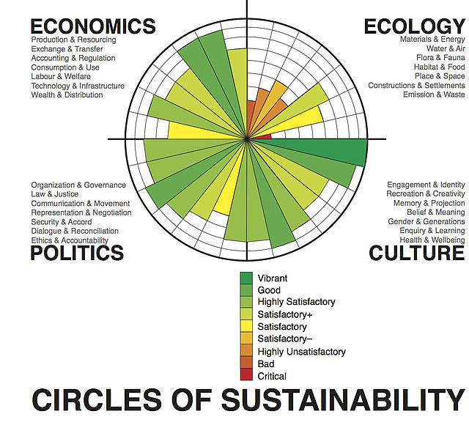 Framing of sustainable development progress according to the Circles of Sustainability, used by the United Nations
Other organizations have also supported the idea of a fourth domain of sustainable development. The Network of Excellence "Sustainable Development in a Diverse World", sponsored by the European Union, integrates multidisciplinary capacities and interprets cultural diversity as a key element of a new strategy for sustainable development. The Fourth Pillar of Sustainable Development Theory has been referenced by executive director of IMI Institute at UNESCO Vito Di Bari^{[59]} in his manifesto of art and architectural movement Neo-Futurism, whose name was inspired by the 1987 United Nations’ report Our Common Future. The Circles of Sustainability approach used by Metropolis defines the (fourth) cultural domain as practices, discourses, and material expressions, which, over time, express continuities and discontinuities of social meaning.
The proposal for adding a fourth 'cultural' dimension has not been accepted by all agencies and organizations, some which still argue that economics is primary, and culture and politics should be included in 'the social'.

indicators
A study concluded that social indicators, and therefore sustainable development indicators are scientific constructs whose principal objective is to inform public policy-making. The International Institute for Sustainable Development has similarly developed a political policy framework, linked to a sustainability index for establishing measurable entities and metrics. The framework consists of six core areas, international trade and investment, economic policy, climate change and energy, measurement and assessment, natural resource management, and the role of communication technologies in sustainable development.
The United Nations Global Compact Cities Programme has defined sustainable political development is a way that broadens the usual definition beyond states and governance. The political is defined as the domain of practices and meanings associated with basic issues of social power as they pertain to the organisation, authorisation, legitimation and regulation of a social life held in common. This definition is in accord with the view that political change is important for responding to economic, ecological and cultural challenges. It also means that the politics of economic change can be addressed. They have listed seven subdomains of the domain of politics:
- Organization and governance
- Law and justice
- Communication and critique
- Representation and negotiation
- Security and accord
- Dialogue and reconciliation
- Ethics and accountability
This accords with the Brundtland Commission emphasis on development that is guided by human rights principles.

